Raby Redcurrant & red onion relish
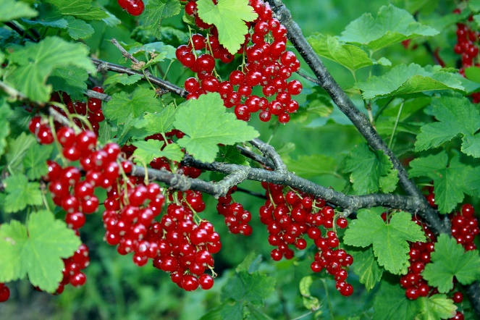
Preparation total time 55 Min

Makes one 400grm pot

Nutrition: per serving (1 Tablespoon)
Kcal  57 | Fat  2g | Saturates  0g | Carbs  11g | Sugars  9g | Fibre  1g | Protein  1g | Low in Salt  0.41g

A delicious sweet chutney, perfect for every occasion, especially with our homemade sausage rolls

Ingredients

- 200g Red Currants
- 140g Light muscovado Sugar
- 200ml Red wine Vinegar
- 2 Medium Red Onions- Peeled and cut into wedges
- 1 Medium Red Pepper- seeded and chopped
- 2 Cloves of garlic.
- 20g Fresh Ginger Grated
- 1 tsp Five Spice
- 1 Small red chilli, seeded and chopped
- 2 Tbsp olive Oil

Method

- Roll the onions with red peppers and Olive Oil in a frying pan for 5-8 min over a high heat until lightly charred and softened. Remove from the pan and set aside.
- Put the chilli, garlic and ginger in the pan with half the vinegar. Bring to the boil then simmer for 2-3 min. Add the onions and pepper plus remaining vinegar, all the sugar, spice and 1tsp salt.
- Bring to the boil then simmer for 5 min until thickened. Add redcurrants and simmer for about 5 mins more.
- Remove and pour into a large heatproof Jar and seal whilst hot
- Will keep in fridge for up to 3 weeks.

Recipe by Estate Chef Tom Parry

